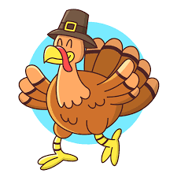
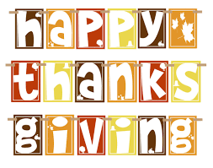
Nov.12-16, 2018
Language Arts
Reading- Compare & Contrast
Writing- Explanatory Essay
Spelling- Book 1, Unit 11
monologue unison solitude
monotone unicorn solo
monotonous unify solar
unique
English- Finish Progressive Verb Tenses *Test Thurs.
Begin Verb Shifts
Math & SS
Math-Division with Decimals & Review of All Decimal Operations *Test Friday
*Multiplication quizzes are Tuesdays!
* All other math quizzes/tests are given as we get to them and not always announced.

Science-Unit 7 Solar System
*Project-Due Dec. 3
*Vocabulary Quiz-Dec. 3
*Unit Test-Dec. 4

Dates to Remember:
11/12-16- American Education Week
Tues. -Wear your College Attire
Wed.-Dress as your Future Career
11/12- Student Council Meets
11/14- Book Club Meets
11/15- Progress Reports Sent Home
PTO Meeting 6pm/Dominoes Night
11/16 Christmas Pictures
Guidance
“Walk the Town” Packet Pick Up @ ATES
11/17- “Walk the Town” 5K event
11/19-23-Thanksgiving Break
11/26-12/7- EasyCbm Testing
11/27-Town of Atoka Tree Lighting 7pm
Important Reminders:
- Remember to study for Science and SS tests throughout the entire unit. Don’t wait until the last day to begin. Study guides and vocabulary terms are glued in the very first day we begin the unit.

- Short Response Answers- We have been practicing a lot in class to use questions from the questions to answer it or in other words restate the question! After progress reports, students will begin losing partial credit if these types of questions are not answered completely. We must dig deeper and add more to our responses.

- New Attendance Incentive- For every week we have perfect attendance, students will be able to sit by whomever they choose in our class at lunch for a solid week!!!

Mon. | Tues. | Wed. | Thurs. | Fri.
Music | Health | Library | Art | PE
Related Arts Schedule
The mission of Atoka Elementary School is to create a challenging learning environment that prepares students for college & career readiness through academic, behavioral, and social achievements.

ATES Webpage-http://ates.tipton-county.com/
Reading: Review of all previously taught material
English: Clauses, Simple Compound, & Complex
Sentences
*Reading & English tests will be announced through Remind101.
Spelling/Vocab: Root Words-hosp, onym, host
hospital homonym hostile
hospitable synonym hostage
antonym
anonymous
acronym
pseudonym
*Spelling Extra Credit- Write Spelling words 5 times each and turn in on Friday with the Spelling test and get 10 extra points. This is optional.
Writing: Narrative

