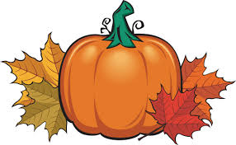
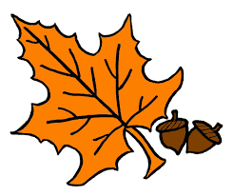
Oct.22-26, 2018
Language Arts
Reading- Historical Texts
Writing- Persuasive Essay Writing
Spelling- Book 1, Unit 9 Quiz Friday*
biology photography Philadelphia
biodegradable photosynthesis philanthropist
biography photon philosophy
bibliophile
English- Prepositions Test Friday*
Math & SS
Math-Division *Please be checking homework! This is a tough unit!!
*Multiplication quizzes are Tuesdays (no longer basic facts). Other math quizzes are given as we get to them and not always announced.

SS-Chapter 2 Civil War: A Nation Divided (3 Week Unit)
*Project Due Oct. 26th
*Vocabulary Test- Oct. 25th
*Chapter 2 Test-Oct. 26th
*Dates are subject to change. These are goals and may have to be pushed back.

Important Reminders:

- Parent/Teacher Conferences are Oct. 22 & Oct. 29. Please sign up at: https://www.signupgenius.com/go/409084ca5a622a0f58-fall2

- Book Fair is open during Parent/Teacher Conferences. Our Book Fair day is this Thursday, Oct. 25th!!

- 5th Grade MASKquerade Ball is on Oct. 26th from 6pm -8pm. Make sure the person who picks up students have I.D. on them.

Dates to Remember:
10/22-26 Red Ribbon Week
Mon.-Wear Red
Tues.-Wear Crazy Socks
Wed.-Wear Favorite Sports Attire
Thurs.-Wear Sunglasses
Fri.-Wear a Hat/Cap Day
10/22 & 29 Parent/Teacher Conferences
10/22 Report Cards come home
10/22-11/2- Yearbook Sales
10/24 Award’s Day 9:30-10am
10/26 5th Grade Classroom Spelling Bee
5th Grade “Mask”querade Dance 6-8pm
10/31 Dollar Day-Wear Your Costume Cost $1
11/16 Guidance

Mon. | Tues. | Wed. | Thurs. | Fri.
PE | Music | Health | Library | Art
Related Arts Schedule
The mission of Atoka Elementary School is to create a challenging learning environment that prepares students for college & career readiness through academic, behavioral, and social achievements.

ATES Webpage-http://ates.tipton-county.com/
Reading: Review of all previously taught material
English: Clauses, Simple Compound, & Complex
Sentences
*Reading & English tests will be announced through Remind101.
Spelling/Vocab: Root Words-hosp, onym, host
hospital homonym hostile
hospitable synonym hostage
antonym
anonymous
acronym
pseudonym
*Spelling Extra Credit- Write Spelling words 5 times each and turn in on Friday with the Spelling test and get 10 extra points. This is optional.
Writing: Narrative

