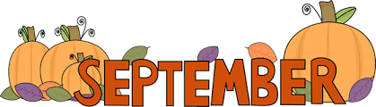
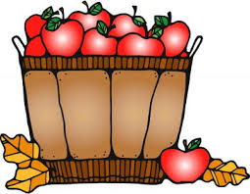
Sept. 10-14, 2018
Reading- AtoZ testing
Writing- Narrative
Spelling- Book 1, Unit 5 Quiz Friday
dictate autobiography inscription
contradict telegram transcript
edict calligraphy prescription
graphic
English- Conjunctions (Coordinating, Subordinating, and Correlative) quizzes will be given throughout (unannounced) with a test at the end (announced later).
Math-Comparing & Rounding/Test on Thursday over everything we have covered this far.
*Multiplication quizzes are Tuesdays. Other math quizzes are given as we get to them and not always announced.
Science-Unit 5 Adaptations
*Vocabulary Quiz-Sept. 14
*Unit 5 Test- Sept. 18
*Dates are subject to change. These are goals and may have to be pushed back.

Important Reminders:

- For Science and SS, make sure your child is studying a little every night. Reread the pages we have read in class. Study the vocabulary words and things we have glued into the journal. Students have to listen and pay attention in class while we are learning. They are required to remember the things we learn in class. It is no longer about regurgitation. Also, the Science book has a built in Study Guide. Look in the journal to see where this study guide is located. Also, students can use the Science textbook website to use the digital lesson that we use in class. I have shown them how to find it multiple times in class. Their username and password is located in their binder.

Dates to Remember:
9/10 Language Arts EasyCbm testing 10am
9/11 Guidance
Carnival Plannning Meeting 6pm
9/14 Make up Pictures
9/17 Student Council Meets
9/19 PTO Yankee Candle Fundraiser Ends
9/20 Running, Art, and Computer Club Meet
Dominoes Night
PTO Meeting 6pm
9/24 PTO Pride Gear Fundraiser Begins
9/25 Carnival Planning Meeting 6pm
9/28 School Spirit Day-Wear your class T-shirt
9/29 PTO FREE Family Movie Night 8pm
11/16 Guidance

Mon. | Tues. | Wed. | Thurs. | Fri.
Art | PE | Computer | PE | Music
Related Arts Schedule
The mission of Atoka Elementary School is to create a challenging learning environment that prepares students for college & career readiness through academic, behavioral, and social achievements.

ATES Webpage-http://ates.tipton-county.com/
Reading: Review of all previously taught material
English: Clauses, Simple Compound, & Complex
Sentences
*Reading & English tests will be announced through Remind101.
Spelling/Vocab: Root Words-hosp, onym, host
hospital homonym hostile
hospitable synonym hostage
antonym
anonymous
acronym
pseudonym
*Spelling Extra Credit- Write Spelling words 5 times each and turn in on Friday with the Spelling test and get 10 extra points. This is optional.
Writing: Narrative

