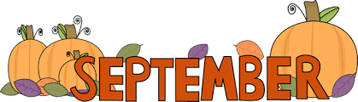
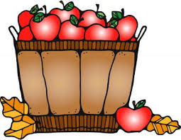
Sept. 4-7, 2018
Reading- Summary
Writing- Narrative
Spelling- Book 1, Unit 4 Quiz Friday
cycle circumference central
cyclical circuit concentric
cyclone circumstance eccentric
circumvent
English- Conjunctions (Coordinating, Subordinating, and Correlative) quizzes will be given throughout with a test at the end. Test will be announced later.
Math-Number Forms/Comparing & Rounding
*Multiplication quizzes are Tuesdays. Other math quizzes are given as we get to them and not always announced.
Science-Unit 5 Adaptations
*Vocabulary Quiz-Sept. 11
*Unit 5 Test- Sept. 12
*Dates are subject to change. These are goals and may have to be pushed back.

Dates to Remember:
9/4 PTO Yankee Candle Fundraiser Begins
9/5 Math EasyCbm testing 9am
Last day to purchase School tshirt ($12)
9/6 Progress Reports & TN Ready Scores
come home
9/10 Language Arts EasyCbm testing 10am
9/11 Guidance
Carnival Plannning Meeting 6pm
9/14 Make up Pictures
9/17 Student Council Meets
9/19 PTO Yankee Candle Fundraiser Ends
9/20 Running, Art, and Computer Club Meet
Dominoes Night
PTO Meeting 6pm
9/24 PTO Pride Gear Fundraiser Begins
9/25 Carnival Planning Meeting 6pm
9/28 School Spirit Day-Wear your class T-shirt
9/29 PTO FREE Family Movie Night 8pm
11/16 Guidance

Important Reminders:

- On graded papers, you will see red ink marks. These are from your child. We self-check a lot of our work. I will not grade in red. I will always use a different color to grade with. If you have any questions, please feel free to ask at any time.
- For Science and SS, make sure your child is studying a little every night. Reread the pages we have read in class. Study the vocabulary words and things we have glued into the journal. Students have to listen and pay attention in class while we are learning. They are required to remember the things we learn in class. It is no longer about regurgitation.

Mon. | Tues. | Wed. | Thurs. | Fri.
 | PE | Music | Health | Library
Related Arts Schedule
The mission of Atoka Elementary School is to create a challenging learning environment that prepares students for college & career readiness through academic, behavioral, and social achievements.

ATES Webpage-http://ates.tipton-county.com/
Reading: Review of all previously taught material
English: Clauses, Simple Compound, & Complex
Sentences
*Reading & English tests will be announced through Remind101.
Spelling/Vocab: Root Words-hosp, onym, host
hospital homonym hostile
hospitable synonym hostage
antonym
anonymous
acronym
pseudonym
*Spelling Extra Credit- Write Spelling words 5 times each and turn in on Friday with the Spelling test and get 10 extra points. This is optional.
Writing: Narrative

